Section 1: Child Population Projections

ONS Mid-Year Estimates (MYE)
Mid-year population estimates relate to the usually resident population. They account for long-term international migrants (people who change their country of usual residence for a period of 12 months or more) but do not account for short-term migrants (people who come to or leave the country for a period of less than 12 months).

Harrow’s 2021-MYE
According to the 2021-MYE, Harrow’s children and young people, age 11 to 25, are estimated to have increased from 2020 to 2021, whilst the pre-school (age 0-4) and primary school age (age 5 to 10) numbers have decreased, as can be seen in the Table 1 below.

Table 1: ONS 2020 & 2021 MYE by Age Groups
Age | Mid-2020 | Mid-2021 | # change | % change
0 to 4 | 17,832 | 15,569 | -2,263 | -12.7%
5 to 10 | 20,516 | 19,379 | -1,137 | -5.5%
11 to 15 | 15,464 | 16,365 | 901 | 5.8%
16 to 19 | 10,952 | 12,068 | 1,116 | 10.2%
20 to 25 | 16,224 | 18,631 | 2,407 | 14.8%
Source: Population Estimates Table (2021)

The ONS were scheduled to have published the 2022 MYE in summer 2023, unfortunately they are yet to be released.

ONS Sub National Population Projections
The ONS’s Population Projections (SNPP) provide statistics on potential future size and age structure of the population. They are based on past trends and assumptions of future levels of births, deaths and migration. They do not incorporate local development plans but instead provide a baseline, which can be combined with local knowledge.

Harrow’s 2018-based SNPPs
According to the ONS’s SNPPs Harrow’s primary age children from 0 to 4 and 5 to 9 are projected to decrease between 2018 and 2028.

According to the ONS’s SNPPs Harrow’s secondary age children from 10 to 19 are projected to continue increasing;

Table 2: ONS 2018 SNPP by Age Groups
Age range | 2018 | 2023 | 2028 | # change 2018-2028 | % change 2018-2028
0-4 | 17,745 | 15,732 | 14,840 | -2,905 | -16.4%
0-9 | 16,783 | 16,919 | 15,059 | -1,724 | -10.3%
10-14 | 15,080 | 16,417 | 16,378 | 1,298 | 8.6%
15-19 | 13,767 | 13981 | 15,142 | 1,375 | 10.0%
20-24 | 13,528 | 11,880 | 11,710 | -1,818 | -13.4%
Source: 2018 SNPP table2

The ONS is yet to announce when the latest SNPP will be available.
GLA Borough Preferred Option Population Projections

The 2020-based BPO projections have been produced with a newly developed small area population model. This model has been developed to reduce reliance on 2011 census inputs in the modelling process. As a result, the model is able to run projections not only for census (2013) wards but also for updated wards including 2022 ward boundaries.

The Borough Preferred Option (BPO) projections are a special set of housing-led population projections produced by the GLA for London local authorities and based on a housing development trajectory specified by each borough for this specific purpose. The BPO projections use the GLA housing-led and small area models to produce ward-level population projections.

The 2021-based BPO projections (produced in early 2023) are produced on 2022 wards boundaries.

Population base and backseries
In December 2022 ONS released the 2021 Mid-Year Estimate (MYE) for local authorities in England and Wales. The 2021 MYE constitutes a break in the official MYE series (2012-2020) as it is based on rolling forward 2021 census data rather than the 2020 MYE.

In order to have a consistent backseries to work with the GLA have modelled a local authority level series between the accepted data points 2011 and 2021. This LA series has been modelled down to output area and then re-aggregated up to 2022 ward boundaries. The result is a consistent ward-level backseries for the period 2011-2021.

However, this process may mean that ward populations in 2021 differ in size and distribution from census 2021 outputs.

Model operation
The BPO projections use the GLA flexible area model to produce ward-level population projections.

The model operates by calculating a population based solely on trends and then separately one based on converting available dwelling stock into population through the application of average household size (AHS). These two populations are then reconciled in the model to produce a final population which accounts for both current trends and relative changes in housing availability.

Migration scenarios
The 2021-based BPO projections include three scenario projections for each development trajectory:

Scenario 1: Ward migration rates are calculated by applying the average of the last 5 years’ rates to projected population. The population, births and deaths are constrained to the 2021-based 5-year migration trend projection.

Scenario 2: Ward migration rates are calculated by applying the average of the last 10 years’ rates to projected population. The population, births and deaths are constrained to the 2021-based 10-year migration trend projection.

Scenario 3: Ward migration rates are calculated by applying the average of the last 10 years’ rates to projected population. The population, births and deaths are constrained to the 2021-based 15-year migration trend projection.
Constraining
The constraining process has the effect of transferring the overarching characteristics of the trend projection, and its detailed migration assumptions, to the ward-level projection.

The trend projections assume the same level of international migration in 2022 (a figure based on ONS data on UK-level international flows for that year). International migration levels then diverge as the variants move towards their long-term levels. These levels are achieved in 2025 and then remain constant to the end of the projection.

Domestic migration levels in the constraining trend projections are calculated by applying averaged rates to projected population in each year of the projection.

2021-based BPO projections
This year we have used the school roll projections that are based on the BPO Scenario 2, in-line with Demography and Planning areas of the Council.

A summary of the GLA’s 2020 Borough Preferred Option population projections based on scenario 2 for Harrow of 0 to 3 year olds, 4-10 year olds, 11-15 year olds and 16 to 25 year olds is summarised in the chart below.

The bullet points and Table 3 below show the estimated number of children in Harrow between 2011 and 2021 by aged group. The number of:

- 0 to 4 year olds increased from 2011 to 2014 and then steadily decreased to 15,575 in 2021.
- 5 to 10 year olds increased from 17,290 in 2011 to 19,378 in 2021. The numbers increased consistently from 2011 to 2018 and started to dip slightly over the last 3 years.
- 11 to 15 year olds increased from 14,892 in 2011 to 16,357 in 2021, with some fluctuation in the years between.
- 16 to 19 year olds has fluctuated between 2011 and 2021, from 12,264 to 12,051 respectively.
- 20 to 25 year olds has declined from 19,641 in 2011 to 18,585 in 2021, with some fluctuation in the years between.

Table 3: GLA 2021 BPO by Age Groups
Age | 2011 | 2012 | 2013 | 2014 | 2015 | 2016 | 2017 | 2018 | 2019 | 2020 | 2021
0 to 4 | 15993 | 16582 | 16949 | 17281 | 17185 | 17246 | 16982 | 16894 | 16805 | 16493 | 15575
5 to 10 | 17290 | 17713 | 18456 | 19020 | 19462 | 19526 | 19745 | 19855 | 19812 | 19682 | 19378
11 to 15 | 14892 | 14691 | 14344 | 14354 | 14678 | 15058 | 15455 | 15912 | 16355 | 16416 | 16357
16 to 19 | 12264 | 12190 | 11826 | 11477 | 11336 | 11517 | 11116 | 10941 | 10902 | 11626 | 12051
20 to 25 | 19641 | 19470 | 18969 | 18686 | 18656 | 18629 | 18501 | 18689 | 18642 | 18893 | 18585
Source: GLA’s Harrow 10 year constrained

The bullet points and the chart below show the population projections by age group from 2022 to 2036.

- The 0 to 4 age group are projected to mostly continue increasing, from 15,493 in 2022 to 16,821 by 2036.
- The 5 to 10 age group are projected to drop from 19,407 in 2022 to 17,577 in 2029 after which the projections start increasing and reach 18,354 by 2036.
- The 11 to 15 age group is projected to continue decreasing from 16,762 in 2022 to 14,775 in 2036.
- The 16 to 19 age group are projected to increase from 12,629 in 2022 to 13,103 in 2028, after which point the projections start decreasing, dropping to 11,801 by 2036.
- The 20 to 25 age group is projected to continue increasing from 19,075 in 2022 to 20,389 in 2020, after which point the projections steadily drop to 19,964 in 2036.

Chart 1: Harrow’s 0 to 25 year old population estimates & projections 2011 to 2036
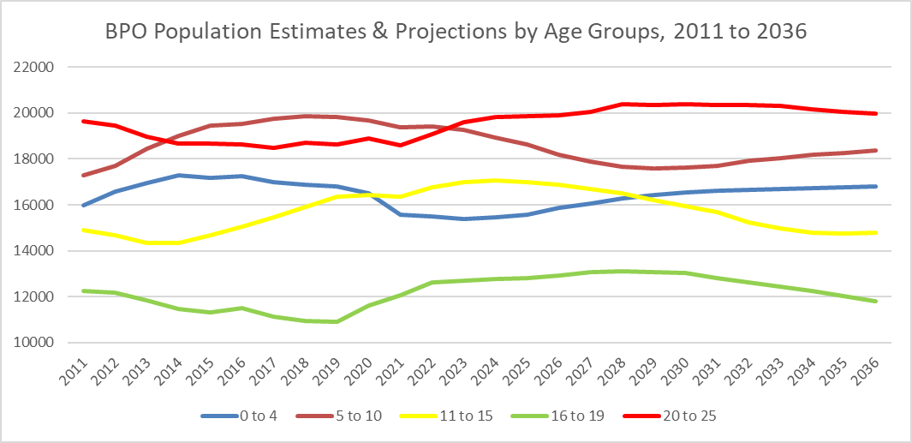
Source: GLA’s Harrow 10 year constrained

The chart below shows that the number of 0 to 4 year olds in Harrow have sharply increased, plateaued and then dropped over the last decade, increasing from from 15,993 in 2011 to 17,281 in 2014 and then falling to 15,493 in 2022. The numbers are projected to stabilise until 2025, after which point they are projected to start increasing again, reaching 16,821 in 2036, with a continued upward trajectory.

Chart 2: Harrow’s 0 to 4 year old population
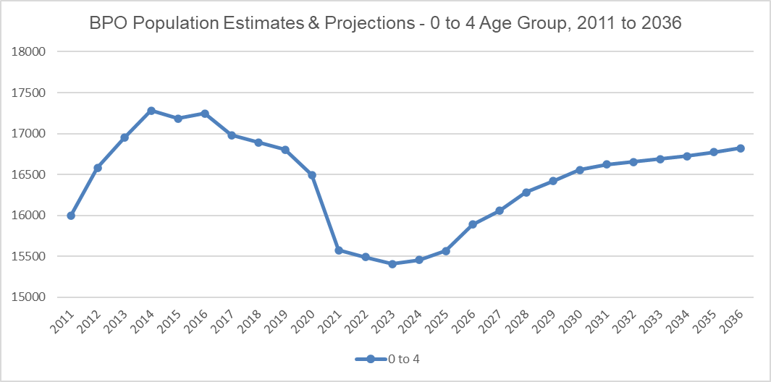
Source: GLA’s Harrow 10 year constrained

Chart 3 below shows that the number of 5 to 10 year olds increased from 17,290 in 2011 to 19,378 in 2021, and are projected to decrease from 19,274 in 2022 to 18,434 by 2036.

Chart 3: Harrow’s 5 to 10 year old population
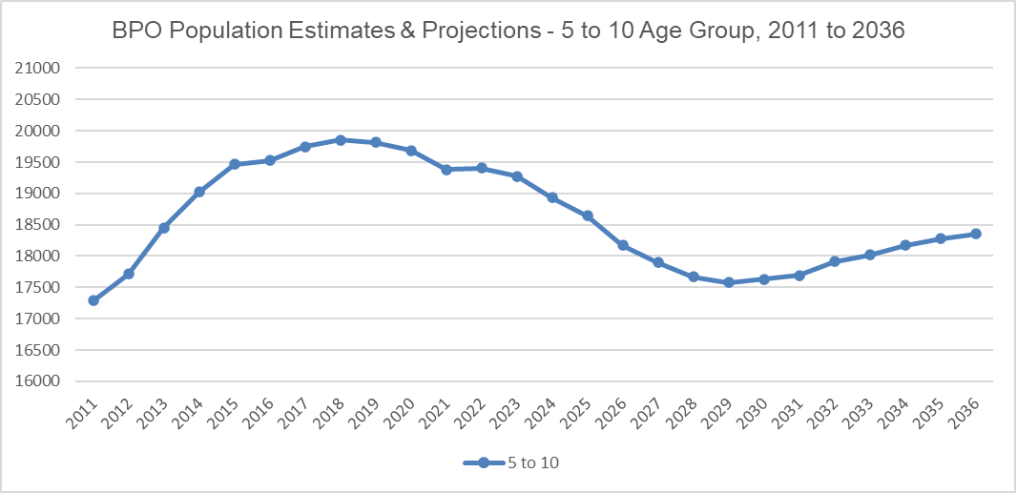
Source: GLA’s Harrow 10 year constrained

Chart 4 below shows that the number of 11 to 15 year olds decreased from 14,892 in 2011 to 14,344 in 2013, and then increased to 16,357 in 2021. The projections are projected to continue increasing, peaking at 17,049 in 2024 and then to decline with a downward trajectory to 14,775 in 2036.

Chart 4: Harrow’s 11 to 15 year old population
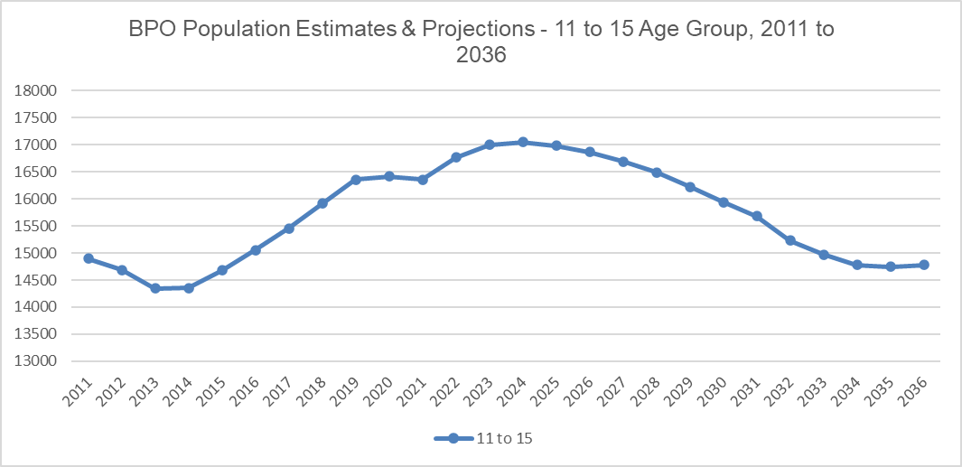
Source: GLA’s Harrow 10 year constrained

Chart 5 below shows that the number of 16 to 19 year olds has dropped from 12,264 in 2011 to 11,336 in 2015, and then rose to 12,051 in 2021. The numbers are projected to continue increasing to 13,301 in 2028 and then start decreasing to 11,801 by 2036.

Chart 5: Harrow’s 16 to 19 year old population
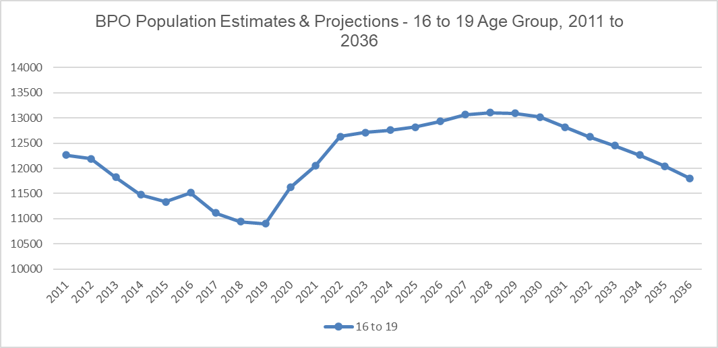
Source: GLA’s Harrow 10 year constrained

Chart 6 below shows that the number of 20 to 25 year olds dropped from 19,641 in 2022 to 18,501 in 2017 and then started to increase, reaching 18,585 by 2021. The projections increase from 19,075 in 2022 to 20,389 in 2030 and then start to drop steadily to 19,964 by 2036.

Chart 6: Harrow’s 20 to 25 year old population
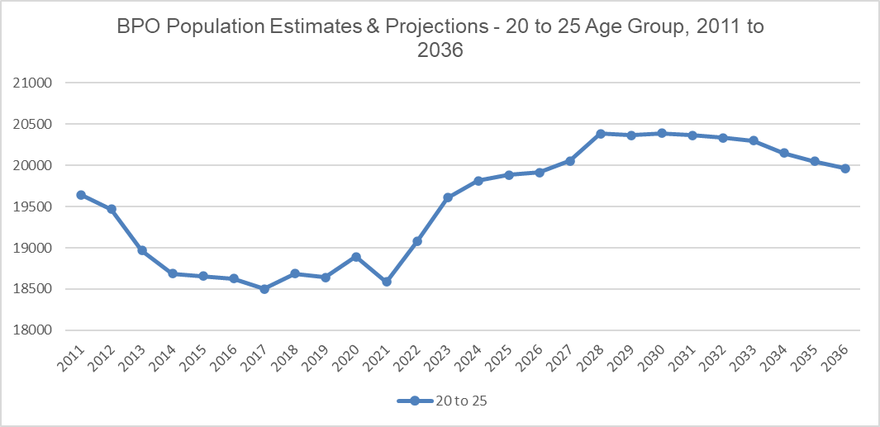
Source: GLA’s Harrow 10 year constrained

Primary Planning Areas
The GLA projections for primary schools are area based, using the Planning Areas created in 2004 by Harrow Council for school place planning when they were changed to reflect boundary changes. The projections for each Planning Area were based on a combination of ward-level child population projections and the historic pattern of subscription to schools.

Historically a methodology was used where schools were placed in planning area based on the wards that majority of the pupils resided in, with the exception of Voluntary Aided Schools. Wards were grouped together geographically taking into account the schools attended by pupils living the ward. Where the percentage of pupils from wards was less than 40% the geographical location of the ward and schools were taken into account. It was decided that the Voluntary Aided primary schools would have a non-geographical planning area as their pupils resided across the borough.

The recent review of the current planning areas is in line with DfE guidance and an analysis of where pupils went to school in May 2021, based on pupils’ postcodes, has been used. The new Primary Planning Areas were redefined using the new May 2022 wards retaining the current methodology as described above. The DfE’s current planning area guidance has strongly recommended not using non-geographical planning areas therefore a decision to not include the voluntary aided primary schools in the existing 5 geographical planning areas has been implemented. This resulted in the deletion of the Volutary Aided primary planning area and Harrow currently has 5 geographical primary planning areas.

Harrow’s Births and Reception Year Rolls
Harrow’s observed births have continued to increase from 2,922 in 2005/06 to 3,620 in 2012/13. Births fluctuated from 2013/14 onwards - dropping to 3,509 in 2014/15, and then increasing to 3,655 in 2017/18 however Harrow’s births dropped to the lowest they have been over the last decade – decreasing to 3,317 in 2020/21, as can be seen in the chart 1 below.

In contrast to the recent decline in births Harrow’s projected births are projected to continue increasing from 3,391 in 2021/22 to 3,686 and beyond, as can be seen in chart 1 below.

Chart 6: Harrow’s Actual & Projected Births
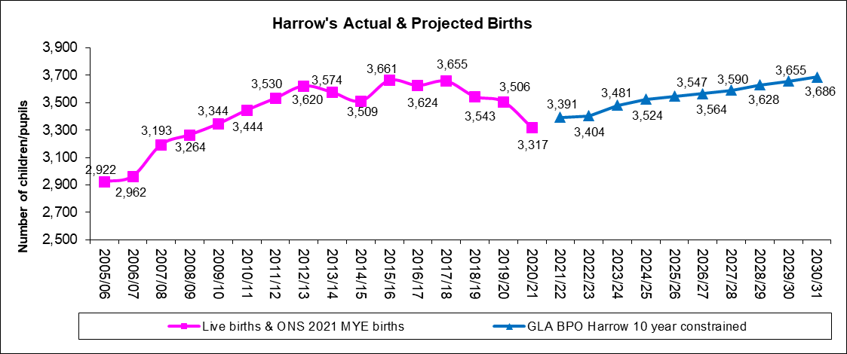
Source: GLA Births Harrow 10 year constrained

In-line with the increase in Harrow’s births Harrow schools’ actual Reception numbers increased from 2,224 in 2005/06 to 3,251 in 2014/15. However, the numbers fell in 2015/16 to 3,198 and then dropped again to 3,152 in 2016/17. Since 2017/18 the reception number have fluctuated, rising slightly to 3,191 but then dropped quite significantly to 3,044 in 2018/19. The 2021/22 Reception number on roll is 3,162. This overall decline in the actual numbers is reflected in the projected trajectory shown in chart 7 below. Due to this change this report includes both the school roll projections as provided by the GLA (referred to as baseline) alongside our local adjustment of 2%.

Chart 7: Harrow’s Actual & Projected Reception Year Rolls
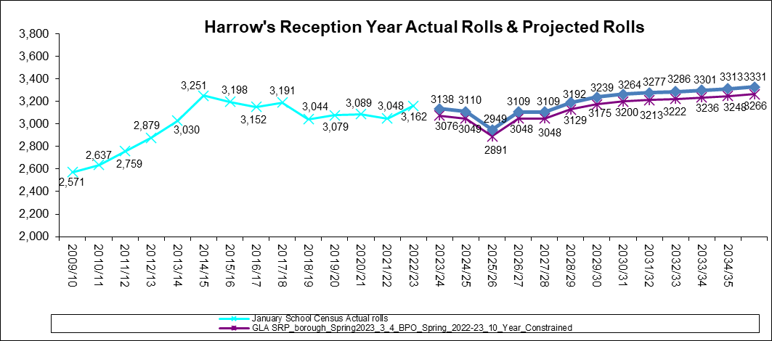
Source: GLA SRP_borough_Spring2023_3_1_BPO202110-year_constrained_1805230626

Births to School Conversion
Harrow’s birth to school pupil conversion rate has ranged from 89% in 2006/07 (representing 2,310 children in Reception in January 2007 from a total of 2,602 births in 2001/02) to 97% in 2014/15 (representing 3,251 children in Reception in January 2015 from a total of 3,344 births in 2009/10). The conversion rate has fluctuated since then, dropping to 84% in 2021/22, however it increased to 87% in 2021/22 (representing 3,162 children in Reception in January 2022 from a total of 3,655 births in 2017/18).

As can be seen by the latest data above the increases in Harrow’s births have not inevitably translated into children accepting a place in Harrow’s schools Reception year group. There are a range of variables that will affect the actual number of births converting into Harrow’s Reception school children, such as migration into and out of the borough, migration out of the country especially of European Citizens returning to their country of origin (likely to be due to both Brexit and or the Covid-19 pandemic),children living on the borders of Harrow could be attending neighbouring boroughs school’s (especially with new free school’s opening in Harrow’s neighbouring boroughs), or even selecting a grammar or an independent school.

Chart 9 below shows Harrow’s 2009/10 to 2019/20 births to actual Reception numbers on roll conversion rate, which has been fluctuating, from 90% in the academic year 2009/10, peaking at 97% in 2014/15, falling to 85% in 2018/19 and increasing to 88% in 2019/20 and then falling again to the lowest retention rate ever – 84% in 2020/21 & 2021/22. However, the latest retention rate in 2022/23 increased to 87%. The chart also shows Harrow’s 2022/23 to 2035/36 projected conversion rate, which is quite steady, ranging between 87% and 89%.

Chart 9 - Conversion rate of Harrow births into actual school Reception numbers on roll
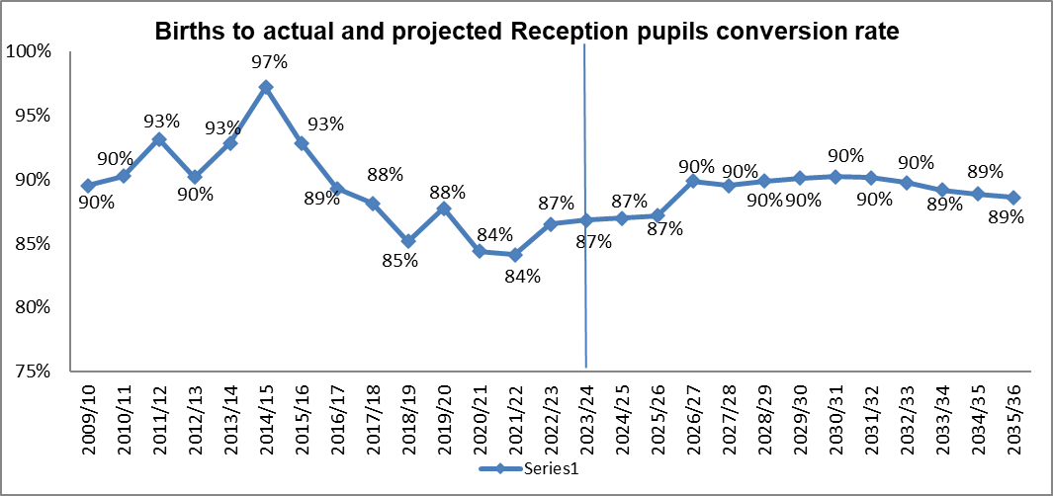
Source: GLA Births Harrow 10 year constrained

Section 2: Local Factors Influencing Harrow’s Pupil Projections

School Admissions Applications, Offers for Places and Take –Up

Residents must apply to their home authority for a maintained school place, whether the school place is within the authority or out of borough. During the Admissions process, applications for a Harrow school from out borough residents are also considered and vice versa. Whilst residents do not apply for an independent school place via the Local Authority, they sometimes do let the authority know that they are sending their child to an independent school.

Reception in-take
The Admissions service experienced an increasing trend until 2014 in the number of on-time, late and in-year applications for Reception and all of the primary phase year groups. Applications for Reception places have fluctuated since 2015 (please see Table 4 below).

Harrow Residents
The Admissions Service received 3,092 applications (as at 10 August 2023) from Harrow residents for a September 2023 Reception year school place; this includes applications for Harrow schools, out of borough schools etc.

Applications and offers of Reception places
The Table 4 below shows the total number of applications over the last few years. This table also illustrates the difference between the number of offers made and the take up of places as measured by the DfE School Census in January. The take-up rate has reverted back to previous years, falling slightly from last year’s rate and this will be monitored.

Table 4: Admissions Reception Entry Applications of Harrow residents
Entry Year | On-time | Lates as at end of August | Total | Increase | % Increase from previous year | January Census | January Take Up Rate
 | January* | ** |  | (Total) |  | Reception
Sep-12 | 2,796 | 318 | 3,114 | - | - | 2,879 | 92.5%
Sep-13 | 2,991 | 330 | 3,321 | 207 | 6.65% | 3,029 | 91.2%
Sep-14 | 3,210 | 238 | 3,448 | 127 | 3.82% | 3,251 | 94.3%
Sep-15 | 3,126 | 288 | 3,414 | -34 | -0.99% | 3,195 | 93.6%
Sep-16 | 3,175 | 264 | 3,439 | 25 | 0.73% | 3,154 | 91.7%
Sep-17 | 3,143 | 243 | 3,386 | -53 | -1.54% | 3,189 | 94.2%
Sep-18 | 2,969 | 205 | 3,174 | -212 | -6.26% | 3,043 | 95.9%
Sep-19 | 2,976 | 212 | 3,188 | 14 | 0.44% | 3,079 | 96.6%
Sep-20 | 3,043 | 184 | 3,227 | 39 | 1.22% | 3,089 | 95.7%
Sep-21 | 2,864 | 311 | 3,142 | -52 | -1.61% | 3,048 | 96.0%
Sep-22 | 2,972 | 278 | 3,250 | 75 | 2.36% | 3,162 | 97.3%
Sep-23 | 2,771 | 321 | 3,092*** | -158 | -4.9% | 3,076 | 99.5%
* On-time applications are the data from the DfE returns submitted on offer day.
** Lates are the number of on-time applications subtracted from the total home (Harrow) applications on the Capita One system. (Note: if the home address of the pupil has changed to an address outside Harrow since the application, this may deflate the total number of late applications)
*** As at 10 August 2023

Year 7 intake

Harrow Residents
Admissions received 3,053 applications (as at 10 August 2023) from Harrow residents for a September 2023 year 7 school place; this includes applications for Harrow schools and out of borough schools and grammar schools.

The Table 5 below shows the increase in the total number of applications over the last few years. It also illustrates the difference between the number of offers made and the take up of places as measured by the DfE School Census in January. The take-up rate has remained at or just above 81% since September 2013, however it has fluctuated since then as can be seen in the table below. The most recent take-up rate increased to 89% in September 2023.

Table 5: Admissions Year 7 Entry Applications of Harrow residents
Entry Year | On-time | Lates as at end of August (2) | Total | Increase | % Increase from previous year | January Census | January Take Up Rate
 | October (1) |  |  | (Total) |  | Year 7
Sep-13 | 2,329 | 129 | 2,458 | - | - | 1,982 | 80.6%
Sep-14 | 2,475 | 167 | 2,642 | 184 | 7.49% | 2,160 | 81.8%
Sep-15 | 2,557 | 167 | 2,724 | 82 | 3.10% | 2,204 | 80.9%
Sep-16 | 2,676 | 142 | 2,818 | 94 | 3.45% | 2,377 | 84.4%
Sep-17 | 2,753 | 75 | 2,828 | 10 | 0.35% | 2,347 | 83.0%
Sep-18 | 2,749 | 139 | 2,888 | 60 | 2.12% | 2,534 | 87.7%
Sep-19 | 2,914 | 104 | 3,018 | 130 | 4.50% | 2,670 | 88.5%
Sep-20 | 2,986 | 83 | 3,069 | 51 | 1.69% | 2,623 | 85.5%
Sep-21 | 2,931 | 122 | 3,053 | -16 | -0.52% | 2,633 | 86.2%
Sep-22 | 2,876 | 135 | 3,011 | -42 | -1.38% | 2,667 | 89.0%
Sep-23 | 2,923 | 130 | 3,503(3) | 42 | 1.39% | 2,716 | 88.6%
(1) On-time applications are the data from the DfE returns submitted on offer day.
(2) Lates are the number of on-time applications subtracted from the total home (Harrow) applications on EMS. (Note: if the home address of the pupil has changed to an address outside Harrow since the application, this may deflate the total number of late applications)
(3) As at 10th August 2023

Harrow primary schools’ pupils’ borough of residence

The number of pupils in Reception to Year 6 in Harrow schools consistently increased from 2005/06 (16,633) to 2019/20 (21,714). The number dropped for the first time in January 2021 (21,480) and again in January 2022 to 21,322 pupils, however it increased to 21,561 pupils in January 2023, in Harrow’s 39 primary and 1 all through school. (Source: Harrow schools’ school census).

The number of out of borough primary age pupils attending Harrow’s schools in previous years increased from 2,031 in January 2016 to 2,301 in January 2019, however they dropped to 2,258 in 2022. The number in January 2023 is 2,265

Table 6 below shows that as at January 2022 the majority (89.5%) of Harrow’s primary school pupils reside within the borough of Harrow.

Table 6: Harrow schools’ Reception to Year 6 pupils Harrow ward of residence January 2023
Ward | Number of Primary pupils on roll | Percentage of primary pupils on roll
Headstone | 1,287 | 6.0%
Edgware | 1,227 | 5.7%
Pinner South | 1,177 | 5.5%
Centenary | 1,163 | 5.4%
Kenton East | 1,094 | 5.1%
Marlborough | 1,092 | 5.1%
Roxeth | 1,068 | 5.0%
Harrow Weald | 1,049 | 4.9%
Wealdstone North | 956 | 4.4%
Greenhill | 914 | 4.2%
Pinner | 834 | 3.9%
Rayners Lane | 815 | 3.8%
West Harrow | 773 | 3.6%
Roxbourne | 769 | 3.6%
Kenton West | 714 | 3.3%
Belmont | 712 | 3.3%
Wealdstone South | 686 | 3.2%
North Harrow | 685 | 3.2%
Stanmore | 650 | 3.0%
Hatch End | 624 | 2.9%
Harrow on the Hill | 553 | 2.6%
Canons | 454 | 2.1%
Harrow Wards Total | 19,296 | 89.5%
Out of borough | 2,265 | 10.5%
Grand Total | 21,561 | 100%
Source – January 2023 School Census NB special schools not included

Residence of Reception Pupils
As at January 2023 there were 3,162 (3,048 in 2022) pupils in the Reception year group and 10.3% (10.3% in 2022) of Harrow schools’ Reception pupils live outside the borough.

In January 2023 the out of borough pupils mainly live in Harrow’s neighbouring boroughs: Brent 110 (120 in 2022), Hillingdon 79 (60 in 2022), Hertfordshire 50 (61 in 2022), Barnet 49 (34 in 2022), Ealing 34 (36 in 2022) and Other LAs 4 (3 in 2022).

In January 2022, 7.5%, 215 pupils, of Harrow’s resident Reception age children attended schools maintained by other local authorities (6.7% in January 2021). In January 2022, 10.7%, 316 children (302, 10.1% in January 2021) of other local authorities children attended schools in Harrow, resulting in the net difference of 3.2% between imports and exports of the school population in Reception for Harrow in 2021/22.

The numbers of primary age pupils exported and imported into Harrow have remained similar and balanced over the last 4 years; however as at January 2022 Harrow imported 695 more children into its schools than it exported into other borough’s schools (619 in January 2021).

Table 29 below shows where Harrow’s resident pupils attend primary schools outside of the borough over the last 4 years. The number of pupils leaving Harrow to attend schools in other boroughs has continued dropping over the last five years, from 1,920 in January 2017 to 1,574 in January 2021.

Table 29: Harrow’s resident pupils attending primary schools in other boroughs
Primary School LA | Pupil residents of Harrow
 | Jan-17 | Jan-18 | Jan-19 | Jan-20 | Jan-21 | Jan-22
Primary Schools in Brent | 521 | 514 | 501 | 500 | 515 | 508
Primary Schools in Hillingdon | 659 | 621 | 567 | 538 | 462 | 442
Primary Schools in Barnet | 431 | 419 | 398 | 385 | 359 | 350
Primary Schools in Ealing | 155 | 147 | 164 | 160 | 171 | 154
Primary Schools in Hertfordshire | 110 | 124 | 114 | 85 | 92 | 87
Other LAs | 44 | 47 | 51 | 47 | 36 | 33
Total Harrow resident pupils exported | 1,920 | 1,872 | 1,795 | 1,715 | 1,635 | 1,574
Source: DfE SFR Cross Border Movement

Table 30 below shows the number of out of borough of residents attending Harrow’s primary schools. The number of out of borough pupils attending Harrow’s schools increased from 2,060 in January 2017 to 2,296 in January 2019 but has dropped since, to 2,269 in 2022.

Table 30: Borough of residence of Harrow’s primary school pupils
LA Name Residence | Primary School in Harrow
 | Jan-17 | Jan-18 | Jan-19 | Jan-20 | Jan-21 | Jan-22
Residents of Brent | 711 | 743 | 789 | 786 | 788 | 803
Residents of Hillingdon | 418 | 441 | 499 | 498 | 512 | 510
Residents of Hertfordshire | 368 | 384 | 450 | 418 | 406 | 438
Residents of Ealing | 307 | 296 | 297 | 283 | 267 | 270
Residents of Barnet | 205 | 204 | 211 | 223 | 230 | 218
Other Las | 42 | 36 | 48 | 48 | 48 | 30
Unknown* | 9 | 6 | 2 | 6 | 3 | 0
Total out of borough pupils imported | 2,060 | 2,110 | 2,296 | 2,256 | 2,254 | 2,269
Source: DfE SFR Cross Border Movement; * Includes pupils with invalid postcodes

Harrow secondary schools’ pupils’ borough of residence
As at January 2022, there were 13,393 pupils on roll (13,061 pupils in January 2022) in Years 7 to 11 in Harrow’s 12 secondary and 1 all through schools.

The number of out of borough secondary aged pupils attending Harrow schools continued to increase from 2,048 in January 2017 to 2,511 in January 2021, a 23% increase but dropped to 2,478 in January 2023.

Table 9: Number of Out of Borough pupils attending Harrow’s Secondary Schools
January | 2017 | 2018 | 2019 | 2020 | 2021 | 2022 | 2023
OoB pupils | 2,048 | 2,134 | 2,335 | 2,468 | 2,511 | 2,485 | 2,478

Table 10 below shows that a majority (81.5%) of Harrow’s high school pupils reside in the borough of Harrow.

Table 10: Harrow schools’ Year 7 to Year 11 pupils Harrow ward of residence January 2023
Ward | Number of pupils | Percentage of pupils
Headstone | 760 | 5.7%
Harrow Weald | 757 | 5.7%
Centenary | 750 | 5.6%
Edgware | 717 | 5.4%
Roxeth | 655 | 4.9%
Wealdstone North | 651 | 4.9%
Pinner South | 585 | 4.4%
West Harrow | 533 | 4.0%
Marlborough | 511 | 3.8%
Kenton East | 509 | 3.8%
Belmont | 459 | 3.4%
Rayners Lane | 425 | 3.2%
Roxbourne | 424 | 3.2%
North Harrow | 421 | 3.1%
Wealdstone South | 408 | 3.0%
Greenhill | 407 | 3.0%
Stanmore | 405 | 3.0%
Kenton West | 391 | 2.9%
Harrow on the Hill | 356 | 2.7%
Pinner | 294 | 2.2%
Canons | 265 | 2.0%
Hatch End | 232 | 1.7%
Harrow wards total | 10,915 | 81.5%
Out of Borough | 2,478 | 18.5%
Grand Total | 13,393 | 100.0%
Source – January 2023 School Census. NB special schools not included.

Residence of Year 7 pupils
As at January 2023 there are 2,667 (2,633 in 2022) pupils on roll in Year 7, of these pupils 440 (478 in 2022) live in Harrow’s neighbouring boroughs - 128 (150 - 2022) in Brent, 95 (93 - 2022) in Ealing, 83 in Hertfordshire (73 in 2022), 67 (83 – 2022) in Hillingdon, 63 (69 – 2022) in Barnet and 4 in other LAs.

DfE Secondary Cross Border Movement

- As at January 2022 the number of secondary age pupils exported from Harrow was 3,662 (January 2021 – 3,648).
- The number imported into Harrow’s high schools was 2,514 (January 2021 – 2,512).
- Resulting in a loss of 1,148 pupils (January 2021 – 1,136), which is lower than the loss in previous years, for example a loss of 1,554 pupils in January 2015.

The table below shows where Harrow’s resident pupils have gone to high schools outside of the borough over the last five years.

Table 31: Harrow’s resident pupils attending high schools in other boroughs
High School LA | Pupil residents of Harrow
 | Jan-17 | Jan-18 | Jan-19 | Jan-20 | Jan-21 | Jan-22
High Schools in Brent | 821 | 862 | 893 | 862 | 882 | 886
High Schools in Hillingdon | 836 | 836 | 868 | 868 | 877 | 868
High Schools in Hertfordshire | 759 | 824 | 841 | 828 | 819 | 808
High Schools in Barnet | 739 | 706 | 699 | 647 | 639 | 691
High Schools in Ealing | 86 | 110 | 92 | 94 | 108 | 122
High Schools in Buckinghamshire | 116 | 143 | 128 | 100 | 89 | 55
High Schools in Slough | 84 | 84 | 80 | 87 | 88 | 91
High Schools in Hammersmith & Fulham | 63 | 54 | 54 | 49 | 48 | 43
Other LAs | 77 | 88 | 92 | 105 | 98 | 98
Total Harrow resident pupils exported | 3,581 | 3,707 | 3,747 | 3,640 | 3,648 | 3,662
Source: DfE SFR Cross Border Movement

Table 8 below shows the number of out of borough residents attending Harrow’s high schools over the last 4 years. This number has increased from 2,148 in January 2017 to 2,514 in January 2022, which represents a 17.0% (366 pupils) increase from January 2017 to January 2022.

Table 32: Borough of residence of Harrow’s high school pupils
LA Name Residence | High Schools in Harrow
 | Jan-17 | Jan-18 | Jan-19 | Jan-20 | Jan-21 | Jan-22
Residents of Brent | 976 | 972 | 935 | 911 | 871 | 891
Residents of Ealing | 384 | 419 | 492 | 542 | 584 | 552
Residents of Barnet | 377 | 393 | 427 | 413 | 389 | 355
Residents of Hillingdon | 172 | 197 | 254 | 306 | 344 | 360
Residents of Hertfordshire | 188 | 225 | 194 | 231 | 255 | 296
Other LAs | 49 | 54 | 51 | 60 | 69 | 56
Unknown* | 2 | 6 | 6 | 5 | 5 | 4
Total out of borough pupils imported | 2,148 | 2,266 | 2,359 | 2,468 | 2,512 | 2,514
Source: DfE SFR Cross Border Movement
* Includes pupils with invalid postcodes

Transferral rate of Harrow primary school pupils to Harrow secondary schools
The number of pupils in Year 6 continued increasing from 2,332 in 2011/12 to 3,083 in 2020/21, however have declined since to 3,035 in 2022/23.

The percentage of Year 6 pupils that have transferred to Year 7 in Harrows’ high schools has stayed steady between 66% and 70% over the last 8 years, with this year’s rate at 69.46%. The remainder of the year 6 pupils are likely to be leaving a Harrow primary school to attend an independent school or a state school in another borough including maintained, voluntary aided and grammar schools.

Table 13 below shows the Year 6 to Year 7 transferral rates for the last 13 years.

Table13: Proportion of Harrow’s Primary School Year 6 pupils (as at the May school census) transferring across to Year 7 in Harrow’s High Schools (as at the October school census)
School Census | Total Yr 6* in Harrow primary schools as at School Census | October School Census | No. of Harrow primary school Yr 6 pupils transferring to Yr 7 in Harrow's high schools as at October School Census* | % transferring | Yr 7 Number* on Roll as at October School Census
May-10 | 2,394 | Oct-10 | 1,709 | 71.4% | 1,972
May-11 | 2,408 | Jan-12** | 1,716 | 71.6% | 2,088
May-12 | 2,333 | Oct-12 | 1,559 | 67.4% | 1,861
May-13 | 2,395 | Oct-13 | 1,592 | 67.1% | 1,980
May-14 | 2,545 | Oct-14 | 1,697 | 66.7% | 2,172
May-15 | 2,597 | Oct-15 | 1,721 | 66.3% | 2,198
May-16 | 2,711 | Oct-16 | 1,783 | 65.8% | 2,371
May-17 | 2,761 | Oct-17 | 1,844 | 66.7% | 2,348
May-18 | 2,791 | Oct-18 | 1,892 | 67.8% | 2,512
May-19 | 2,972 | Oct-19 | 2,072 | 69.7% | 2,659
Jan-20*** | 3,038 | Oct-20 | 2,088 | 68.7% | 2,618
May 2021 | 3,085 | Oct-21 | 2,056 | 66.6% | 2,627
May 2022 | 3,078 | Oct-22 | 2,137 | 69.4% | 2,651
*The numbers on roll do not include special school pupils;
**The October 2011 data was not available for Academies, so the January 2012 school census was used instead.
***The May 2020 school census did not occur due to the Covid-19 pandemic.

Retention rate of Harrow secondary schools

The number of pupils in Year 7 in Harrow’s secondary schools in October 2022 increased slightly to 2,651 from 2,627 in October 2021. The retention rate is calculated as a percentage of the number of pupils on roll in Year 7 in the October census to that of the number of pupils on roll in Year 6 in the May census. This retention rate has remained at or over 85% over the last 7 years. In October 2022 there were 2,651 pupils on roll which is 86.1% of the number of pupils on roll in May 2022 in Year 6.

Table 14: Year 7 Retention Rates
May School Census* | Year 6 | October School Census* | Year 7 | Yr 7 as % of previous Yr 6
May-10 | 2,394 | Oct-10 | 1,972 | 82.4%
May-11 | 2,408 | Jan-12** | 2,088 | 86.7%
May-12 | 2,333 | Oct-12 | 1,861 | 79.8%
May-13 | 2,395 | Oct-13 | 1,980 | 82.7%
May-14 | 2,545 | Oct-14 | 2,172 | 85.3%
May-15 | 2,597 | Oct-15 | 2,198 | 84.6%
May-16 | 2,711 | Oct-16 | 2,371 | 87.5%
May-17 | 2,761 | Oct-17 | 2,348 | 85.0%
May-18 | 2,791 | Oct-18 | 2,512 | 90.0%
May-19 | 2,972 | Oct-19 | 2,659 | 89.5%
Jan-20 | 3,038 | Oct-20 | 2,618 | 86.2%
May-21 | 3,085 | Oct-21 | 2,627 | 85.2%
May-22 | 3,078 | Oct-22 | 2,651 | 86.1%
*The numbers on roll do not include special school pupils;
**The October 2011 data was not available for Academies, so the January 2012 school census was used instead.
***The May 2020 school census was not collected due to the Covid-19 pandemic.

If you compare the transfer rate in table 9 and the retention rate in table 10, this indicates that some of the 30% of pupils who did not transfer at the end of Year 6 from a Harrow Primary School into Year 7 of a Harrow secondary school are replaced by children from outside the borough. The retention rate will be monitored closely to identify any emerging trends arising as a result of changes to secondary school provision in Harrow with the opening of new and additional secondary places.

